***Creating a Data Narrative for Instacart Grocery Orders Dataset***

This project aims to create a data narrative using the Instacart grocery orders dataset. The dataset contains information on more than 3 million grocery orders from over 200,000 Instacart users, including details about the orders placed, the sequence of products purchased, the time and day of the order, and more.

The project will follow the following steps:

**Acquiring Data:** The orders.csv file and the orders_products_train.csv file will be related to create a custom data source for every visualization. Tableau will automatically select join types based on the fields used in the visualization.

**Defining the Audience:** The audience will be defined to ensure that the data narrative is tailored to their needs and interests.

* The primary audience for the communication consists of several groups, including key decision makers and stakeholders such as store managers, senior leadership, the sales executive team, the business intelligence team, and the marketing team. The key decision makers in the audience are the senior leadership, which includes the CEO, CFO, CMO, and CTO, as well as the regional sales managers and business development heads of the sales team. While the senior leadership has shallow knowledge of the data, the sales team has deep knowledge of sales and customers.
* The audience cares about enhancing user engagement and retention, boosting sales and order volume, and maintaining economic and technological relevance in the market. Based on the analysis conducted, the marketing team should organize multiple campaigns offering discounts throughout the weekend, establish a partnership with leading locally sourced organic brands, and focus on targeting households and restaurants.
* It is essential for the company to understand its sales data to make informed decisions, avoid financial instability, and achieve long-term success. The big idea is to organize marketing campaigns that target specific days, times, and customer demographics to increase sales revenue and identify any shortcomings. By doing so, the company can maintain its economic and technological relevance in the market and avoid failures.

**Data Analysis:** The data will be analysed in several sections to gain insights and develop the storyline. The analysis will include:

a) Service Analysis: This section will analyse the busiest days of the week, the busiest hours, the top 10 products in the busiest hours, and the days since the prior order.

b) Product Analysis: This section will analyse the best-selling products, the top 10 products on the first order, the top 10 reordered products in terms of their probability of being reordered, and the number of items purchased in an order.

c) Category Analysis: This section will include a treemap of aisles and products, highlighting the most popular aisles and top products.

**Curate your Views:** The best evidence displaying insights will be curated into visualizations, including worksheets such as Busiest Hours, Busiest Days of the Week, Days Since Prior Order, Number of Items Purchased, Best Selling Products, Treemap of Aisles and Products, and the six Top Products per Group worksheets.

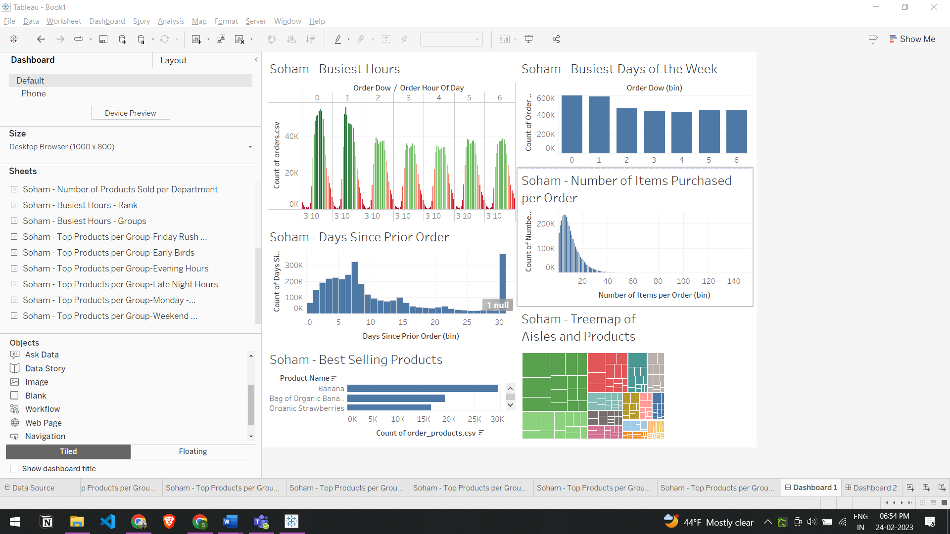

**Organizing the Storyline with Storyboarding:** The storyline will be organized using Freytag’s Pyramid, and story points will be listed in a storyline sequence.

Freytag’s Pyramid:

1. Busiest Hours: Exposition (Beginning)
2. Best Selling Products: Inciting Incident
3. Busiest Days of the week: Rising Action
4. Number of Items Purchased: Climax
5. Days Since Prior Order: Falling Action
6. Treemap of Aisles and Products: Resolution

**Creating a Story in Tableau:** A story will be created in Tableau using the curated visualizations and organized storyline.

**Adding Rhetoric to Your Story:** The analysis will be shaped into a story about a new promotional program for reducing the time between grocery orders, using the appropriate rhetoric for this purpose. Here we have used logical rhetoric approach.

**Formatting the Story:** The data narrative will be polished and formatted for high-grade publishing.

Overall, this project will provide valuable insights into Instacart's grocery orders dataset and create a compelling data narrative to communicate those insights effectively.